- Do a Keystroke Level Model (KLM) for following task (a,b,c.)
Assume that the user’s hand starts on the mouse. Also assume that the trash icon is visible at the time the user wishes to delete the file. Also assume the task is performed by the poor typist.
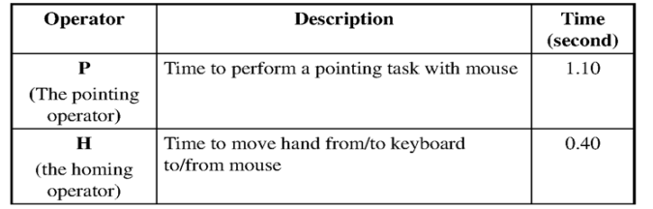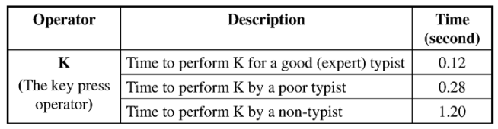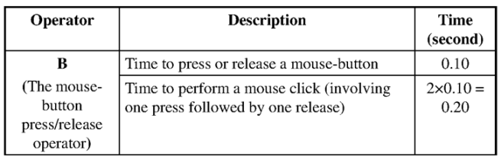
  - Delete a file using drag to trash method

  - Delete a file using delete key method

  - Delete a file using mouse and select delete option (using the mouse for the yes (confirm))

